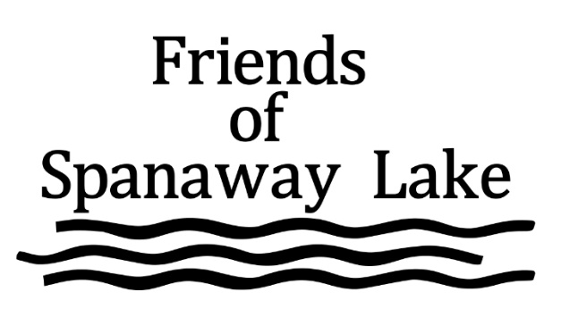
March 13th , 2019
A 501C3 NonProfit Washington State Corporation dedicated to the protection of the beneficial uses of Spanaway lake for all lake Users.
FriendsofSpanawayLake@gmail.com
https://www.facebook.com/FriendsofSpanawayLake/
Phone: 253-218-1242
634 169th St. S. Spanaway, WA. 98387

Senator Conway:
PO Box #######
Olympia, WA. #######

The Friends of Spanaway Lake (FOSL) is requesting your support for funding in the 2019 budget to protect and restore this social, economic, ecological and recreational natural resource in Pierce County (29th district).

Spanaway lake is an urban lake with Pierce County’s second largest regional park. The park provides multiple services to over 500,000⁽¹⁾ persons per year covering a broad social/economic range of Pierce county residents. This park user population has economic benefits to the stores, restaurants, and service providers in the Spanaway/Parkland area. Spanaway lake is a designated urban lake providing year-round fishing, boating, and other watersport services. Environmentally, the lake has hosted a historic run of various salmon species, several of which are related to current Orca recovery efforts.

Spanaway lake has been increasingly impacted by the urban community around it though the increase in nutrients that have altered the lake ecology promoting toxic algae blooms, invasive species, and bacterial concerns. A state funded study in 2015 determined that if early action was not taken that the lake would become effectively unusable within 20 years. FOSL was created by the concerned citizens that were part of the study advisory board to take actions to protect the lake. FOSL now works closely with county agencies to identify actions needed to protect the lake so it may continue to provide the beneficial uses important to the community. FOSL is now managing a contract for the county to conduct a aquatic plant survey. FOSL has worked closely with UPS on studies of the lake chemistry in conjunction with our own studies on temperature and pH. FOSL provides extensive information to the Tacoma Pierce County Health Department and Parks on toxic algae conditions on the lake. FOSL has won two grants from the Clover/Chambers Creek Watershed association to address social and environmental concerns.

FOSL, in conjunction with our partners, has determined that there are a need for three immediate actions to initiate and promote actions to restore the beneficial uses.

- A nutrient fictionalization study focused on phosphorous needs to be conducted to determine the sources of nutrients that are triggering the toxic algae blooms. Without this study it is difficult to identify the best, lowest cost and effective options to be pursued. The study would be managed by FOSL in cooperation with Pierce County agencies and local universities. Current estimate if $40,00 per year for two years.
- Invasive plant harvesting equipment is needed to follow-up on the aquatic plant study being conducted in 2019. FOSL is already aware that 100% of the lake has been infested with invasive lily pads. Other invasive aquatic plants contribute to unsafe swimming, boating and related recreational uses. Additionally, aquatic plant removal would have a small, but measurable, reduction in nutrients in the lake. This harvester would allow us to take action based on the aquatic plant survey being conducted now. Another benefit is that when the harvester is not in use on Spanaway lake it would be available for agencies / organizations to use for permitted aquatic plant harvesting. Current purchase estimates is $70,000 for the capital costs and included training.

Attached are two charts to provide a summary of the conditions of Spanaway Lake based on the original 2015 study. FOSL will provide such additional information as you may require in making your determination to support these requests.

Sincerely,

Sandy Williamson - Board Chair
Scott Munson - Board Co-Chair
Elizabeth Inslen - Board, Communications
Ed Lawson - Board, projects
Jim Overway - Board, operations

